**This product is designed to be used in airsoft, paintball and tactical training purposes by way of airsoft related grenade launchers that are used in the games mentioned.**

**For higher efficiency, the product is recommended to be used with short barrel launchers such as M-203 (short), GP-25 (30), Spike Tactical “HAVOC”. According to their purpose (pyro-explosive, non-pyro, smoke or dummy), the shells (or rounds) have a specific upper body cover coloring:**

| Product Code | Type, Ignition method. | Sound Report | Fragmentation radius | NEC* |  |
| --- | --- | --- | --- | --- | --- |
| RPR-M2 | Pyro-explosive, 3.5 +/- 1sec. delay. 40 BBs payload. | 120Db | 10 Meters | 0.9g  +/-0.1g | body - Black; upper cover - yellow |
| RGL-M2 | Pyro-explosive, impact activated – sound report | 120Db | 3 Meters | 1.17g | body - Black ; upper cover – ribbed white |
| VLM-M2 | Smoke Projectile | N/A | N/A | 18g  SC** | body - Gray ; upper cover - black |
| T25 | Pyro-explosive 4 sec.+/- 1sec. delay, or impact - 80 BB. inside | 120Db | 10 Meters | 0.9g  +/-0.1g | body - Black ; upper cover - gray |
| PLD | Non-pyro, paint-powder inside | N/A | N/A | N/A | body - body - Black ; upper cover - blue |
| PCR | Non-pyro, dummy | N/A | N/A | N/A | body - Black ; upper cover - white |

**\*NEC – Net Explosive content, **SC – Smoke Composition.**

**The shells can be shot out only from a TAGinn launching devices, which goes in a set (or separately).**

**The flight path of a shell depends on gas type, air temperature and varies from 70 to 190 meters. or near the area where shells could be fired.**

**WARNING:**

* **Law enforcement officers or other people may mistake the product for a real firearm. Changing, altering, removing or obliterating the coloration or markings required by state, federal laws or any other regulations so as to make the product look more like a firearm, is dangerous and may be treated as an administrative offense.**

**WARNING:**

* **The open display, brandishing and/or exposing the product in public places may cause confusion and may be a crime.**

**The term “public places” implies any area opened to public, including (but not limited to) streets, sidewalks, bridges, alleys, plazas, parks, driveways, front yards, parking lots, automobiles, whether moving or not, and buildings opened to the general public including those that serve food or provide entertainment, and the doorways and entrances to buildings or dwellings.**

**WARNING:**

* **The product is intended solely for use by responsible individuals at 18 years of age or older. Paintball and airsoft players should comply fully with generally recognized safety standards.**

**Shells are only for use in paintball, airsoft and tactical training, following safety warnings is obligatory. Minors should use shells under close adult care and supervision. When using the product, approved goggles, facemasks, and ear protection must be worn at all times by all persons in.**

**Only a special airsoft gas is allowed to be used as a working medium:**

* **Power gas “Shel EVO” launching devicer**
* **Green gas “Shel EVO” launching devicer**
* **C02 (max 350 psi) for “Shel EVO” launching devices**
* **CO2 (800 PSI) for “Shell-PRO-EVO” launcher 850 PSI High Presuure Air or Nitrogen for “Shell HPA”.**
* **WARNING:**
* **When refilling the cartridge do not use C02, Nitrogen Air or any other gas which pressure exceeds 350 psi for “Shell” launching devices;**
* **Do not point on any part of yourself**
* **Do not point the loaded cartridge to people and animals;**
* **Do not fire a shot at an angle of less than 20 degrees;**
* **Before use make sure there are no people in the shooting zone except players in protective 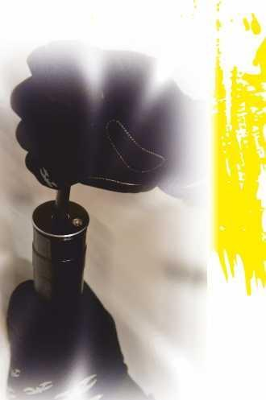ammo, eyes and head gears allowed by the equipment rules.**

**DANGEROUS:**

**Wear the goggles at all steps!**

**Step 1: Use a stick to push the fire button (Primer).**

**A click sound indicates that the valve is in the off-status. Remove the stick, and the button should go back to the original position.**

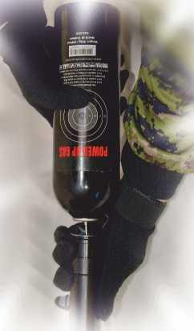**Step 2: Refill the gas cylinder as the picture illustrates. In case of leakage, please go back to step 1.  
  
Note: Every product is designed for a particular pressure use. If you use improper pressure, it may cause leakage and therefore the O-ring damage. If you observe the constant leaking, please contact the retailer or relevant service center and replace the O-ring.  
  
Note: Filling the “Shell-PRO” and “Shell-VOG” possible with “FiSt”™ adapter only.**

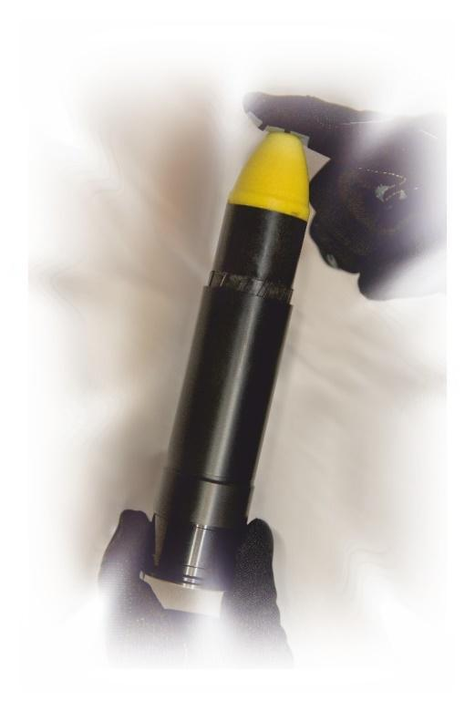

**Step 3: Load the projectile into the barrel.   
  
Note: Wear goggles during the whole process. After you load the round, please restore the low-pressure cartridge carefully and avoid the impacts, or it will cause damages.**

**Do not use your finger to push the button!**

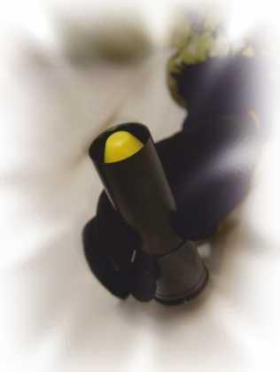

**Step 4: Load the cartridge into the grenade launcher. Remember, do not use your finger to push the fire button or it will fire immediately and cause damages.**

**Don't use your finger to push the button!**

**Important Notice:**

1. **This cartridge is designed only for TAGinn™ projectiles.**

**Unauthorized modifications will cause damage.**

1. **You MUST refill the gas to check if there is a leak first and then load the round. Otherwise, the leaking gas may fire the rounds and cause damage.**
2. **“Shell” launching device is designed for an airsoft “power gas”. If you use high pressure gas (over 350 p.s.i.), it may cause leaking and damage the O-ring.**
3. **“Shell-PRO” and “Shell-VOG” launchers may be used with CO2 (800 PSI).**
4. **Modifying is not allowed. If you find problems with your cartridge, consult with your local dealer.**
5. **Maintenance: Please, use silicon oil to lubricate the components frequently.**
6. **Replace constituent parts only with the original factory parts in order to ensure the quality and safety.**

* **Please keep the projectiles in a dry place at the temperatures between -10’C and +40’C.**
* **Keep away from children.**
* **Use the full face mask and other protective equipment during the game or training.**
* **Follow the general safety guidelines of the training/gaming facility.**
* **If duds (failed to initiate products) are found, hand it over to a field manager or instructor.**

